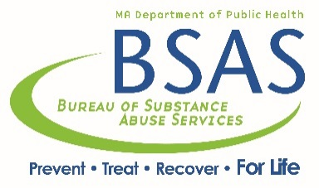

BSAS AUTHORIZATION FORM - ATR Providers

This is to notify Advocates for Human Potential (AHP) that DPH/BSAS has authorized the following provider. Please send to: skratz@ahpnet.com

Full Legal Name of Provider:
Address of Provider:
City/Town: State: Zip Code:
Type of Service Approved
☐ Purchasing/Basic Needs (Take individuals shopping. Write checks)
☐ Health and Wellness - Describe:

☐ Recovery Coaching
☐ Transportation (Bus passes. T passes. Charlie Cards)
☐ Groups – Describe:

☐ Faith Based Services – Describe:

☐ Housing Search
☐ Job training (either job readiness or occupational training)

Signature of DPH/BSAS Representative:
Date ___________________________
Contract Number __________________

